Cloud Storage: Qwik Start - Cloud Console

30 minutes1 Credit

Rate Lab

**GSP073**



**Overview**

Cloud Storage allows world-wide storage and retrieval of any amount of data at any time. You can use Cloud Storage for a range of scenarios including serving website content, storing data for archival and disaster recovery, or distributing large data objects to users via direct download. In this hands-on lab you will learn how to use the Cloud Console to create a storage bucket, then upload objects, create folders and subfolders, and make those objects publicly accessible.

**Setup and Requirements**

**Before you click the Start Lab button**

Read these instructions. Labs are timed and you cannot pause them. The timer, which starts when you click **Start Lab**, shows how long Google Cloud resources will be made available to you.

This Qwiklabs hands-on lab lets you do the lab activities yourself in a real cloud environment, not in a simulation or demo environment. It does so by giving you new, temporary credentials that you use to sign in and access Google Cloud for the duration of the lab.

**What you need**

To complete this lab, you need:

* Access to a standard internet browser (Chrome browser recommended).
* Time to complete the lab.

**Note:** If you already have your own personal Google Cloud account or project, do not use it for this lab.

**Note:** If you are using a Pixelbook, open an Incognito window to run this lab.

**How to start your lab and sign in to the Google Cloud Console**

1. Click the **Start Lab** button. If you need to pay for the lab, a pop-up opens for you to select your payment method. On the left is a panel populated with the temporary credentials that you must use for this lab.

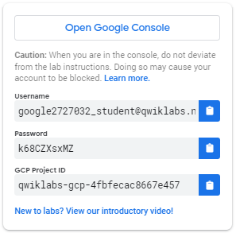

1. Copy the username, and then click **Open Google Console**. The lab spins up resources, and then opens another tab that shows the **Sign in** page.

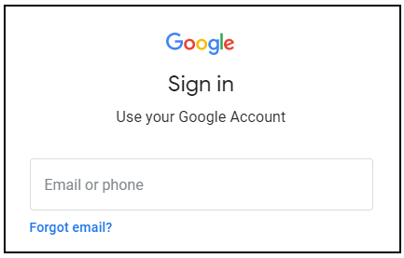

***Tip:*** Open the tabs in separate windows, side-by-side.

If you see the **Choose an account** page, click **Use Another Account**. 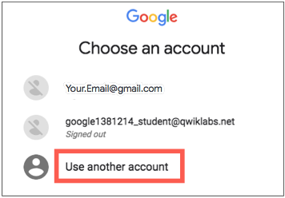

1. In the **Sign in** page, paste the username that you copied from the Connection Details panel. Then copy and paste the password.

***Important:*** You must use the credentials from the Connection Details panel. Do not use your Qwiklabs credentials. If you have your own Google Cloud account, do not use it for this lab (avoids incurring charges).

1. Click through the subsequent pages:
   * Accept the terms and conditions.
   * Do not add recovery options or two-factor authentication (because this is a temporary account).
   * Do not sign up for free trials.

After a few moments, the Cloud Console opens in this tab.

**Note:** You can view the menu with a list of Google Cloud Products and Services by clicking the **Navigation menu** at the top-left. 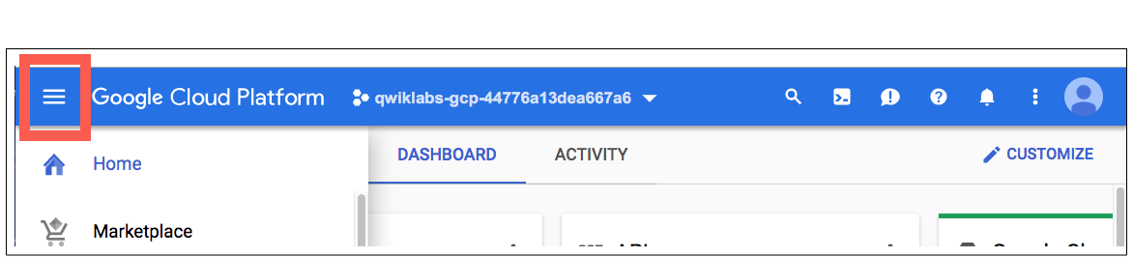

**Create a Bucket**

In the Cloud Console, go to **Navigation menu** > **Storage** > **Browser**. Click **Create Bucket**:

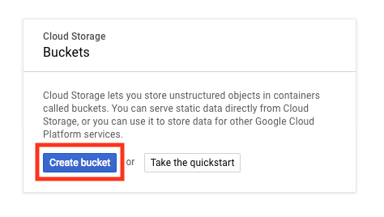

**Name:** Enter a unique name for your bucket.

**Bucket naming rules:**

* Do not include sensitive information in the bucket name, because the bucket namespace is global and publicly visible.
* Bucket names must contain only lowercase letters, numbers, dashes (-), underscores (\_), and dots (.). Names containing dots require [verification](https://cloud.google.com/storage/docs/domain-name-verification).
* Bucket names must start and end with a number or letter.
* Bucket names must contain 3 to 63 characters. Names containing dots can contain up to 222 characters, but each dot-separated component can be no longer than 63 characters.
* Bucket names cannot be represented as an IP address in dotted-decimal notation (for example, 192.168.5.4).
* Bucket names cannot begin with the "goog" prefix.
* Bucket names cannot contain "google" or close misspellings of "google".
* Also, for DNS compliance and future compatibility, you should not use underscores (\_) or have a period adjacent to another period or dash. For example, ".." or "-." or ".-" are not valid in DNS names.

**Storage class:** Multi-Regional

**Location:** United States

Once you've gotten your bucket configured, click **Create**:

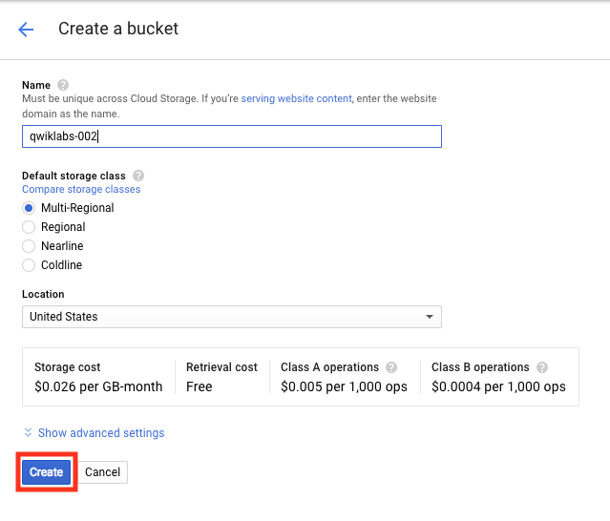

That's it — you've just created a Cloud Storage bucket!

Test Completed Task

Click **Check my progress** to verify your performed task. If you have successfully created Cloud Storage bucket, you will see an assessment score.

Create a bucket.

Check my progress

**Test your Understanding**

Below are multiple choice questions to reinforce your understanding of this lab's concepts. Answer them to the best of your ability.

Every bucket must have a unique name across the entire Cloud Storage namespace.



True



False

Cloud Storage offers which storage classes:



Nearline



Coldline



Standard



Archive

Submit

**Upload an Object into the Bucket**

In this section, you will add an object to your bucket. For this lab the object is an image.

1. Use an image you have on your computer, or [click this link to download a portrait of Ada Lovelace](https://upload.wikimedia.org/wikipedia/commons/thumb/a/a4/Ada_Lovelace_portrait.jpg/800px-Ada_Lovelace_portrait.jpg) and save the image to your local computer.
2. The Bucket details screen should still be open. Drag the portrait of Ada Lovelace to the **Drop files here** area of the Bucket details screen.

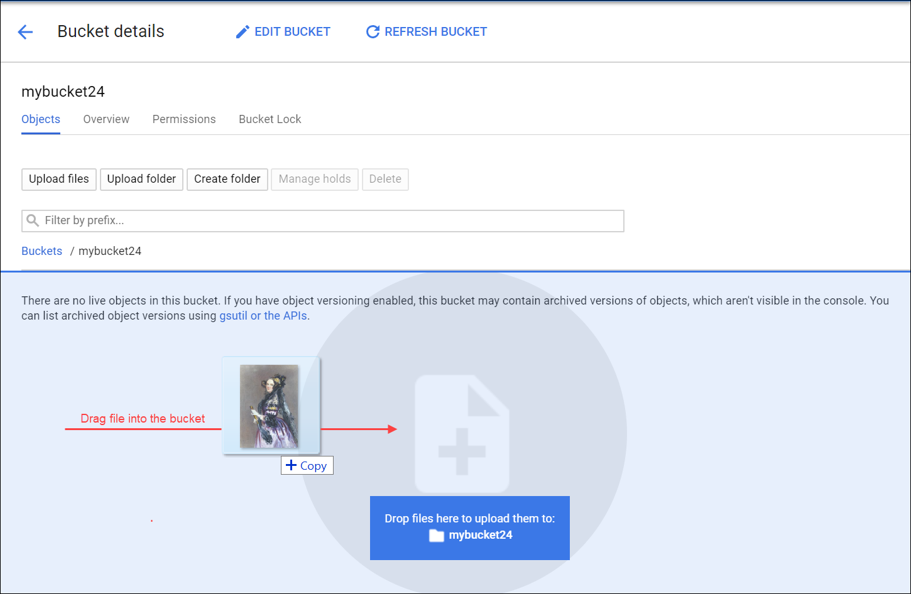

You should see the image listed in the **Buckets** list.

1. Delete the image in the bucket. Check the box next to the filename then click **Delete**, and then click **Delete** again to confirm in the Delete selected file? dialog.
2. Upload the image again, this time click **Upload files**.
3. Navigate to the image on your local computer, and then click **Open**.

You should see the image listed in the **Buckets** list.

1. Rename the file. Click on the drop-down menu (three vertical dots) on the far right on the image row and select **Rename**.

You may have to widen the browser window to see the drop-down menu (three vertical dots).

1. Update the file name to "ada.jpg" and click **RENAME**.

You should now see one file, ada.jpg, in your bucket.

Test Completed Task

Click **Check my progress** to verify your performed task. If you have successfully uploaded object in your bucket, you will see an assessment score.

Upload an object into the bucket (ada.jpg)

Check my progress

**Test your Understanding**

Below are multiple choice questions to reinforce your understanding of this lab's concepts. Answer them to the best of your ability.

Object names must be unique only within a given bucket.



True



False

**Share an Object Publicly**

To create a publicly accessible URL for the object, click the drop-down menu (three vertical dots).

Select **Edit permissions** from the drop-down menu.

In the dialog that appears, click the **+ Add entry** button.

Add a permission for all users by entering in the following:

* Select **Public** for the Entity.
* Enter **allUsers** for the Name.
* Select **Reader** for the Access.

Then click **Save**:

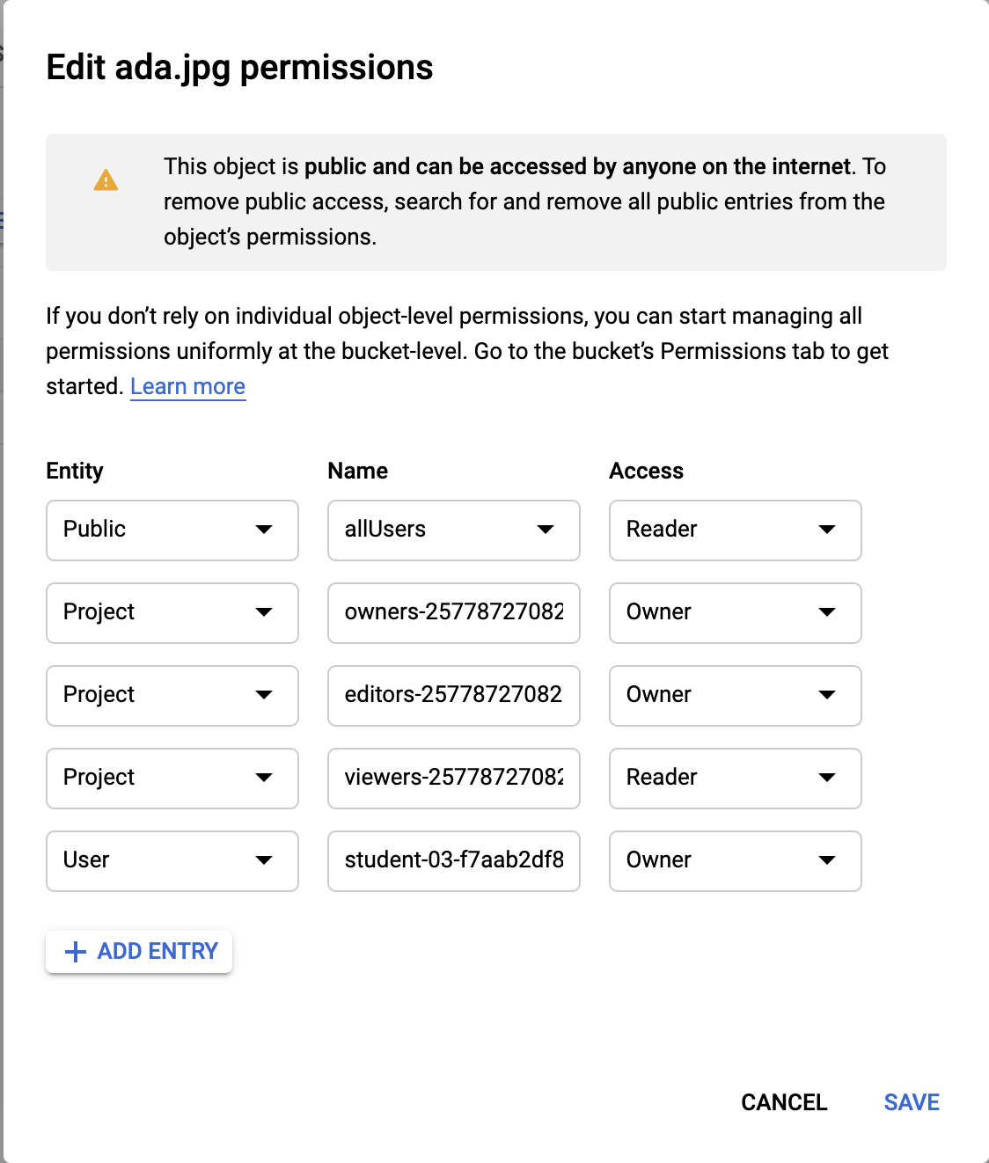

Once shared publicly, a link icon will appear in the public access column. Click the link to open the file in a new tab.

Test Completed Task

Click **Check my progress** to verify your performed task. If you have successfully shared object publicly from your bucket, you will see an assessment score.

Share an ada.jpg object publicly.

Check my progress

**Create Folders**

In this section you will create a folder.

1. Click the **Create Folder** link near the top of the page.
2. Name the folder folder1, then click **Create**.

You should see the folder in the bucket with a folder icon to distinguish it from other objects:

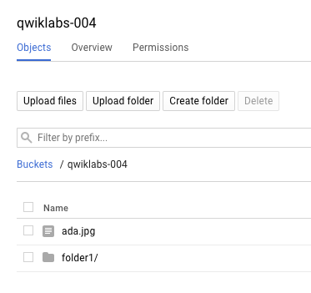

Create a subfolder

Now you'll create a folder inside folder1 and upload a file to it.

1. Click on **folder1**, then click **Create Folder** near the top of the page.
2. Name the folder folder2, then click **Create**.
3. Click on **folder2**.
4. Drag the portrait of Ada Lovelace from your local computer and drop it into the **Drop files here** area.

After the file uploads, you see it listed in the subfolder in the bucket.

1. Rename the file to "ada.jpg".
2. To create a publicly accessible URL for the object, click the drop-down menu (three vertical dots) on the far right of the ada.jpg object.
3. Select **Edit permissions** from the drop-down menu.
4. In the dialog that appears, click the **+ Add entry** button.
5. Add a permission for all users by entering in the following:

* Select **Public** for the Entity.
* Enter **allUsers** for the Name.
* Select **Reader** for the Access.

1. Then click **Save**:



Once shared publicly, a link icon will appear in the public access column—click the link to open the file in a new tab.

Who are you looking at? This is [Ada Lovelace](https://en.wikipedia.org/wiki/Ada_Lovelace" \t "_blank), credited with being the first computer programmer. She worked with mathematician and computer pioneer Charles Babbage, who proposed the [Analytical Engine](https://en.wikipedia.org/wiki/Analytical_Engine). Her interest in the Analytical Engine lead her to translate a paper on the machine by Italian mathematician Luigi Menabrea, and adding her own extensive annotations. These notes are considered the first computer program - an algorithm designed to be carried out by the machine. She developed a vision of the capability of computers, going beyond number crunching, and examined how individuals and society relate to technology as a collaborative tool. Citation: [Ada Lovelace](https://commons.wikimedia.org/w/index.php?title=Ada_Lovelace&oldid=176490980" \t "_blank) (last visited August 16, 2018).

**Delete a folder**

In this section, remove folder1 and its contents from your bucket.

1. Navigate back to Buckets/[YOUR\_BUCKET]. You should see folder1 listed in the bucket contents list.
2. Check the box next to the Name, folder1, and click **Delete**, and then click **Delete** again when prompted to confirm.

folder1 and its contents are no longer in your bucket.

**Congratulations!**



Finish Your Quest

This self-paced lab is part of the Qwiklabs [Baseline: Infrastructure](https://google.qwiklabs.com/quests/33) Quest. A Quest is a series of related labs that form a learning path. Completing this Quest earns you the badge above, to recognize your achievement. You can make your badge (or badges) public and link to them in your online resume or social media account. [Enroll in this Quest](http://google.qwiklabs.com/learning_paths/33/enroll) and get immediate completion credit if you've taken this lab. [See other available Qwiklabs Quests](http://google.qwiklabs.com/catalog).

**Next Steps / Learn More**

This lab is also part of a series of labs called Qwik Starts. These labs are designed to give you a little taste of the many features available with Google Cloud. Search for "Qwik Starts" in the [lab catalog](https://google.qwiklabs.com/catalog) to find the next lab you'd like to take!

Google Cloud Training & Certification

...helps you make the most of Google Cloud technologies. [Our classes](https://cloud.google.com/training/courses) include technical skills and best practices to help you get up to speed quickly and continue your learning journey. We offer fundamental to advanced level training, with on-demand, live, and virtual options to suit your busy schedule. [Certifications](https://cloud.google.com/certification/) help you validate and prove your skill and expertise in Google Cloud technologies.

Manual Last Updated July 23, 2020

Lab Last Tested July 23, 2019

Copyright 2020 Google LLC All rights reserved. Google and the Google logo are trademarks of Google LLC. All other company and product names may be trademarks of the respective companies with which they are associated.